Categories and Subject Descriptors
Michael Jason A. Torres
BS in Information Technology
University of Mindanao
09228081290, Philippines 8000
michaeljason_torres@umindanao.edu.ph

Ivy V. Ybiernas
BS in Information Technology
University of Mindanao
09096576547, Philippines 8000
ivyybiernas@outlook.com

Lady Sheen A. Gilbang
BS in Information Technology
University of Mindanao
09103572769, Philippines 8000
lsgilbang@gmail.com

Fe B. Yara
Master of Science in Information Science
University of Mindanao
09063260253, Philippines 8000
fe_yara@umindanao.edu.ph

Data Profiling and Progress Monitoring Application with Data Analytics Technique for Archdiocesan Nourishment Center

[Stand-alone Application] Data Analytics Technique
General Terms
The general terms used are: Data Analytics and Decision Support System
Keywords
Data Profiling, Progress Monitoring and Archdiocesan Nourishment Center (ANC)

INTRODUCTION

Project Context

Because of the existence of technology, Organizations with many transactions use automated system. Upgrading into automated system helps not only the synchronization of data but also the accuracy. Systems are created to address problems in some organization. Having these systems helped organizations for an easier daily transaction.
Archdiocesan Nourishment Center(ANC) located at Pag-asa St. Davao City is a non-profit charitable organization for children handled by nuns and priests. This organization is supported by volunteers and is given donations by donors. Every day they welcome children who visit the center to have meal. A nutritionist helps them monitor the health progress of each child who visits them, every month they conduct check-ups to see if the child has improved their health or not, and house visitations quarterly to monitor their family.
The problem is ANC has difficulty in monitoring the progress of each child and come up with possible diagnosis based on their current results examined by their medical staffs. They are also having difficulties in analyzing medical and nutritional status of children, difficulties in determining and comparing statistic report and lastly difficulties in determining children that requires the most medical attention and currently in critical alert status. They currently don’t have the technology that would help them for such problems.
Data analytics is a helpful platform that would leverage conventional and untraditional data sources. Since the problems of the organization require comparison and progression of data because they need to monitor the children’s status, data analytics is a secure platform and informed tool selection that would give accurate analysis to the children’s nutritional status and progress. How this is done is through a data integration and visualization which combine and dynamically present data to understand trends and relationship. The type of data analytics the researchers will make is a quantitative data analysis. It would provide a numerical value that would compare and measure statistically. This analysis would compare the historical data of the children and the current data with the use of analysis. With the help of data analytics, there is a quality in the data assessed since those are valid robust supporting data.
Therefore, data analytics technologies and techniques will help them because it is widely used in commercial industries to enable organizations to make more-informed decisions. The data that are analyzed are consist of both previous and current information that has been processed for real-time analytics.

Purpose and Description

The main purpose of the proposed study is to provide a computerized data profiling and progress monitoring application with data analytics technique to easily track the child’s nutritional progress, analyze their medical and nutritional status based on the data profiling provided.

Data Profiling and Progress Monitoring Application is an application which will help ANC in terms of handling the nutritional status of each child under their program. Basic information gathered from Child Information Sheet, Household Information Sheet and Medical Information will be inputted for Data Profiling. All gathered data will be stored in centralized database and will be used for data analysis. With the incorporation of Data Analytics Technique in this application, not only this application will help them in terms of monitoring child’s nutritional status, but it will also help them analyze medical status such as the increase and decrease of BMI and possible causes of nutritional problems. It will also give notifications that will help them determine which children need immediate medical attention. Lastly this application will also generate and provide statistic reports they require.

Objectives

GENEREAL OBJECTIVES
The main goal of the researchers is to develop a Data Profiling and Progress Monitoring Application with Data Analytics Techniques such as Regression Analysis and Decision Tree Analysis for Archdiocesan Nourishment Center.

SPECIFIC OBJECTIVES
To accomplish the general objective, the group aim to develop an application specifically to:

Create a system for children’s data profile for progress Monitoring.

Analyze the medical and nutritional status of the Archdiocesan Nourishment Center (ANC) children using Data Analytics Techniques (Regression Analysis and Decision Tree Analysis).

Generate recommendations for possible treatment such as what vitamins/medicines to take and proper nutritional diet or provide proper meal plan using Decision Support System.

Generate statistical report in graphical representation using Highcharts Interactive JavaScript charts.

Notify the medical staffs regarding children that requires immediate medical attention, prioritization and medical schedules using JQUERY tool.

Scope and Limitation

The proposed application is a stand-alone application that will be used by Archdiocesan Nourishment Center. This application will allow them to create children profiles then monitor and analyze the nutritional status of each child with the help of data analytics technique and decision support system. This application will only focus on the monitoring of nutritional status of the children and not on the intensive medical aspects in determining the health status of each child.

REVIEW OF RELATED LITERATURE/ SYSTEMS

TECHNICAL BACKGROUND

In this chapter, the researchers will discuss the development process of data profiling and progress monitoring application with data analytics technique and decision support system. The current and proposed system will also be discussed.

IPO1: Conceptual Framework

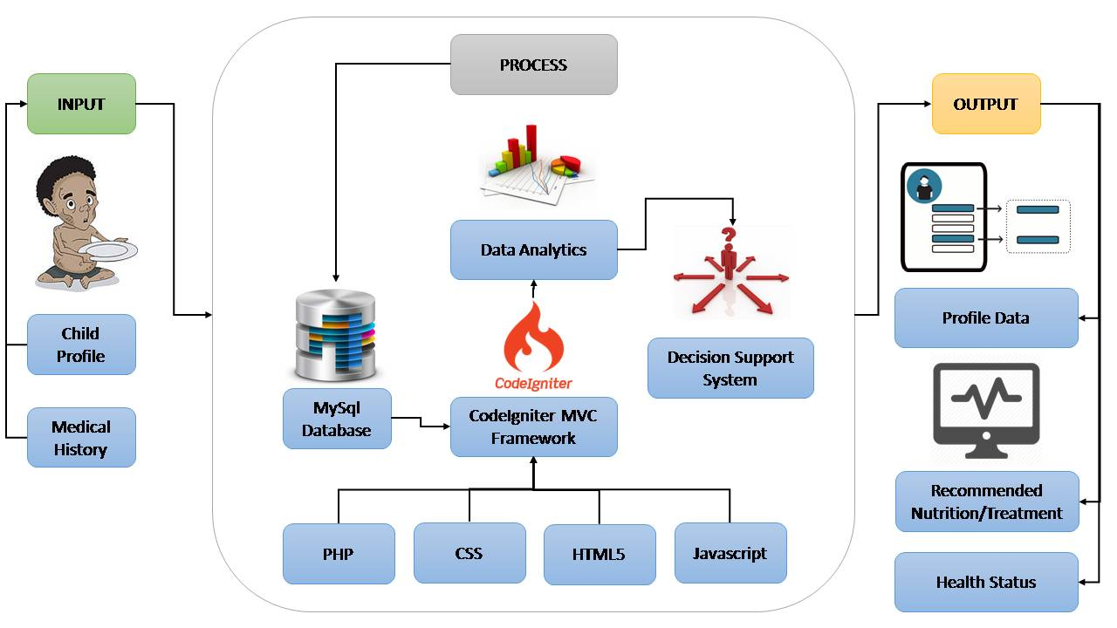

Figure 1: Conceptual Framework

The first step of the proposed system is, the user will input the child’s basic information such as Name, date of birth, place of birth, age, sex, religion, initial weight, initial height, disability (if any), contact number, school the child is enrolled, home address, grade level, etc. Inputting family member’s information is also included in the system such as name, sex, relation to the child, age, marital status, educational attainment, occupation and income. Medical history of the child is a factor in data analytics as well as the weight and height, so it should be properly inputted in the system for analysis. After all the information are being recorded, the next step is the system will process the records and will be stored in the database MYSQL. Then, the CodeIgniter MVC Framework which is a tool for Data Analytics (which will be discussed in IPO2) that is composed of programming languages such as PHP, CSS, HTML5, JavaScript will access the Database then it would generate a Decision Support System (which will be discussed in IPO2). The system will then output a profile data of the child with the health status and recommended Nutrition/Treatment.

IPO2: Data Analytics and Decision Support System Process

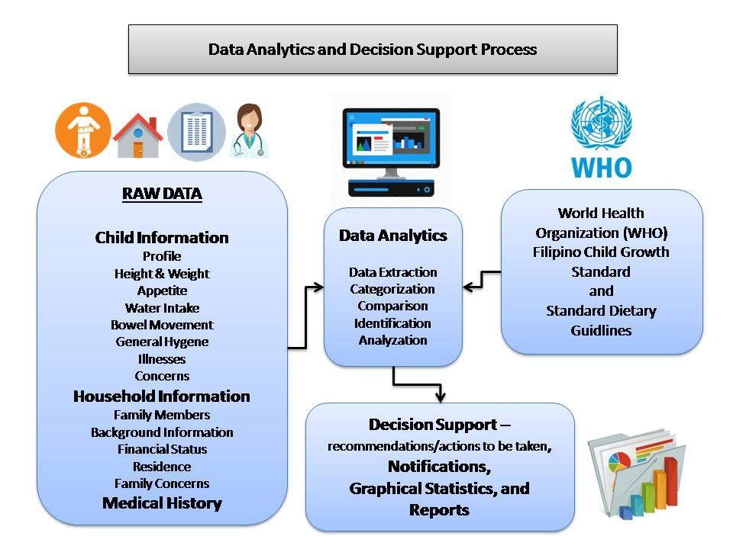
Figure 2: Data Analytics and Decision Support System

Figure 2 shows the process of data analytics and decision support system. By definition, Data analytics refers to qualitative and quantitative techniques and processes used to enhance productivity and business gain. Data is extracted and categorized to identify and analyse behavioural data and patterns, and techniques vary according to organizational requirements. [13] While Decision Support also known as DSS is a computer program application that analyzes business data and presents it so that users can make business decisions more easily. It is an "informational application" (to distinguish it from an "operational application" that collects the data in the course of normal business operation). [14]

Based from the World Health Organization (WHO) Filipino Child Growth Standards (see tables 1 and 2 for samples) and Standard Dietary Guidelines as baseline and from the raw data gathered such as Child Information, Household Information and Medical History. Data analytics techniques such as Regression Analysis and Decision Tree Analysis will be utilized, and Data Analytics will be applied by Data Extraction, Categorization, Comparison, Identification and Analyzation.

Since Regression Analysis involves how an independent variable affects the dependent variable, this technique will show how dependent variable changes when independent variable varied. For example, with data such as age, height and weight, the age is the independent variable while height and weight are dependent to age, since age is a continuous quantitative data, as age increases the required height and weight also increases.
Regression analysis is also a way of mathematically sorting out which of those variables does indeed have an impact. It answers the questions: Which factors matter most? Which can we ignore? How do those factors interact with each other? And, perhaps most importantly, how certain are we about all of these factors? [15]
To further explain on how does Regression Analysis works, the researchers have provided an example process based on the ANC‘s contextual statistical data.

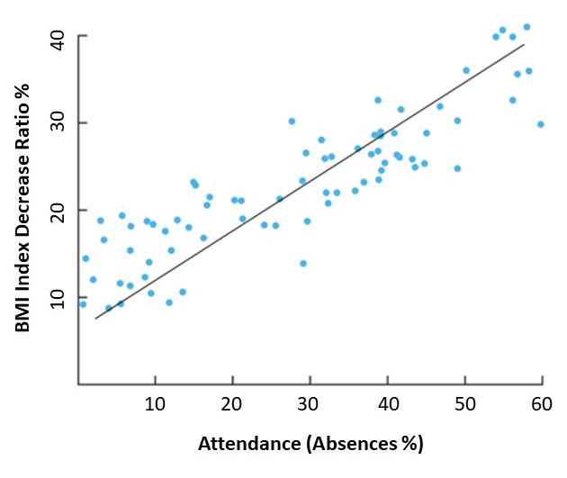

Figure 3: Regression Analysis Example

The y-axis is the amount of BMI index decrease ratio in percentage (the dependent variable) and the x-axis is the attendance (absences percentage). Each blue dot represents one month’s data—how much absences and falling nutritional status percentage, they had the same month. Then come up with conclusion regarding the effectiveness of their current programs
Based on the graphical data shown, the amount of decrease in BMI index corresponds to the amount of absences committed during that month. The higher the BMI decrease ratio, the higher the absences. Therefore, absences greatly affect the nutritional status of the beneficiaries. It gives them the idea to further assess and enhance their programs and activities each month or conduct more home visitations.

For the proposed system, simple linear regression will be utilized. A linear regression line has an equation of the form ŷ = β₀ + β₁ x_{ἰ}, where x_{ἰ} is the independent variable and ŷ_{i} is the predicted value of dependent variable. The slope of the line is β₁, and β₀ is the intercept (the value of y_{i} when x_{i} = 0). Dependent variable will be the weight(kg) of the child, while height(cm) and age(months) will be the independent variables. Since the independent variables will constantly goes up, the dependent variable should also go up which will give a positive relationship. The formula of β₁ and β₀:
β₁= 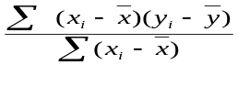
β₀=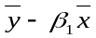
where = is the mean(average) of the x values and = is mean(average) of the y values.
The regression line is the “line of the best fit”, from this, the weight inputted each month will be monitored if it fits in the regression line. A residual value ℯ_{i} will be computed base from the difference between the predicted value of dependent variable, ŷ_{i}, and the true value of dependent variable, y_{i}. ℯ_{i} = ŷ_{i} - y_{i}. The higher the residual value the higher the distance of the true value of dependent variable from the regression line.
This will be shown in each child profile and in the statistical module.

Another technique the researchers will use is the Decision Tree Analysis also known as Classification Tree Analysis. By definition, a decision tree as a predictive model is to go from observations about an item (represented in the branches) to conclusions about the item's target value (represented in the leaves). It is one of the predictive modeling approaches used in statistics, data mining and machine learning. [16]
The Decision Tree Analysis will help as a decision support. For example, a child has a failing nutritional status and considered as severely wasted (acute malnourished). The system will find out what are the possible causes based on various factors leveled accordingly by their significance.

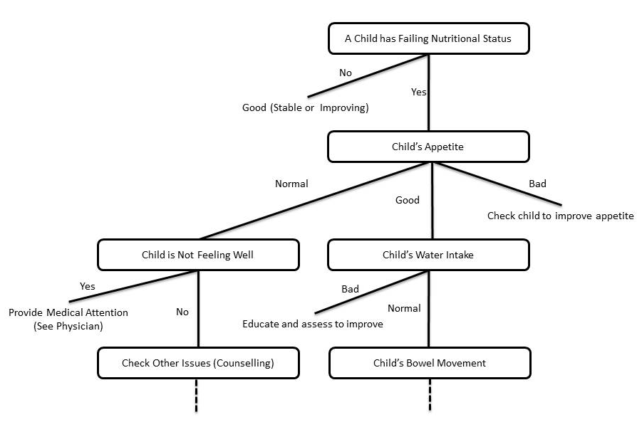
Figure 4: Decision Tree Analysis Example
According to ANC’s Nutritionists some factors of failing nutritional status are Illnesses, Appetite, Water Intake, Bowel Movement, General Hygiene, Behavior, Environment, etc. These factors are levelled accordingly by the system to provide a better overview on the problems that affects such issues and further assess the child’s nutritional status by gradually monitoring these problems along the way to its progression.
By extracting data from the CIS, HIS and Medical History of the children, it will identify, compare and analyze the data whether it belongs to a specific category or not. Another example is when data are extracted such as age, height and weight. It will be used to calculate and identify the Body Mass Index (BMI) of the child. After getting the BMI index value, it will be compared with the growth standard and will be analysed whether it belongs to these categories: N (Normal), UW (Underweight), St (Stunted), SS (Severely Stunted), SU (Severely Underweight), W (wasted), etc.
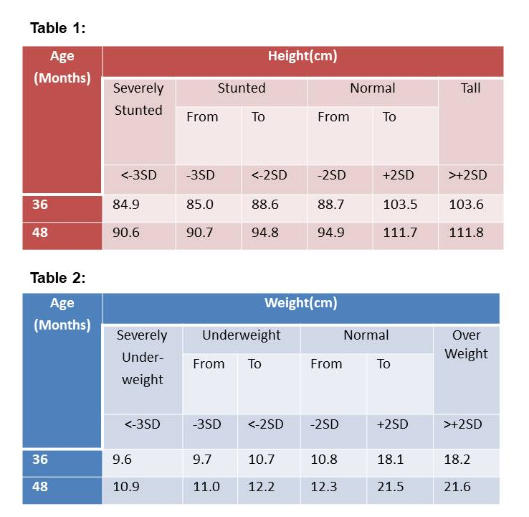
Figure 5: Height and Weight Status Tables
Since Decision Tree Analysis is used as decision support, after the analysis of extracted data, this technique will help give recommendations/suggestions and remarks for each category. For example, if a child has a status below normal the system will generate recommendations/suggestions like what vitamins to take, possible treatments, proper nutritional diet, and how long the child should be monitored. While for normal category, some remarks will be given for logs and future custom analysis. This will be shown in each child profile.
Lastly, system notifications, graphical statistics and reports will also be generated to further represent the system’s gathered information and analysis.

IPO3: System’s Infrastructure
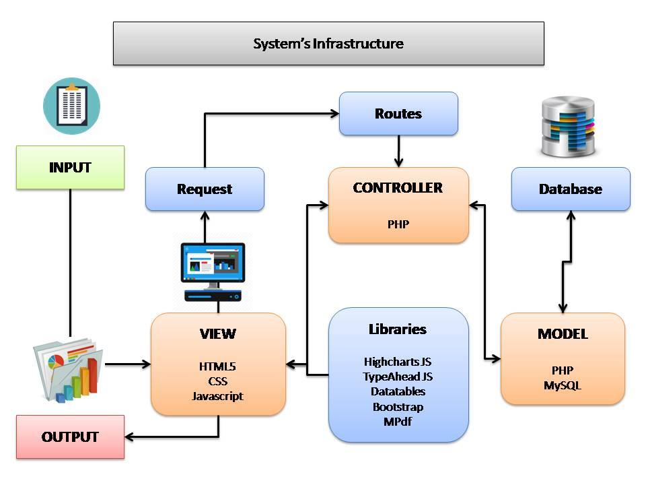

Figure 6: System’s Infrastructure
Figure 6 shows the process of the system’s infrastructure. The system’s infrastructure shows that the user will input the data to the view which is the graphical user interface (GUI) of the system. It is composed of various programming languages such as HTML5, CSS, and Javascript. HTML5 provides the structure of the web pages, CSS is for the designing part, and Javascript is for the client-side processing language that handles the client-side logic of the system. The system will then send a URL request to the routes upon every submission of a form. The routes will handle the routing of the system by sanitizing and providing an alias in every URL request. The controller will handle the request and provide server-side validations for every input. Both javascript and PHP will work hand in hand for the validations. Javascript is for the client side while PHP is for the server-side validation. The controller will then evaluate and process the input through PHP server-side processing language by calling methods in the model. The model is responsible for all the system’s database processes. It is the one that sends queries, combine sql statements, and sanitize database inputs and outputs to prevent sql injection problems. The model is connected to the MySQL database, which serve as the database storage of all the system’s data. The system request will then return a response in the form of an output. The model will send the generated output of the query to the controller then the controller will send it to the view. The view will access the library tools connected to the system such as Highchart JS for generating graphical representation of information, Typeahead JS for multi-functional selection box or combo box, Datatables for tables that are highly flexible, adds advanced interaction controls to HTML table, has sorting, paging and filtering abilities powered by Javascript. Bootstrap for design framework, and MPdf for generating PDF converted reports.

Current System

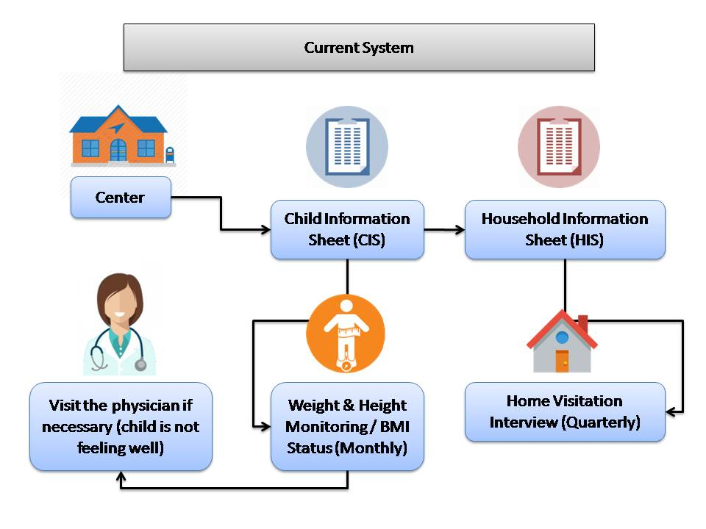

Figure 7: Current System

Figure 7 shows the current process in Data profiling of children of Archdiocesan Nourishment Center:

The first step is that children will visit the ANC, and children will enroll in their nutritional program, Information such as Name, Birthday, Place of birth, Age, Sex, Religion, Initial Weight, Initial Height, Disability (if any), Contact number, Home Address and Date of registration of the children will be written in their Child’s Information Sheet(CIS).
The next step is that ANC’s volunteers particularly social workers will visit the house of the child enrolled in their program to gather the household information, Information such as Ngalan sa Ulohan sa Pamilya (Head of the Family), Address, Mga Meyembro sa Pamilya (Members of the Family) and Date Interviewed will be Written in their Household Information Sheet(HIS). Then every quarter they will visit the household again to do Home Visitation Interview. Each quarter, they will gather and record information such as height, weight, appetite, water intake, bowel movement, general hygiene, date and time of the visit.

Lastly, monthly monitoring of height and weight of the child will be conducted to check BMI status. They can also visit the physician anytime if necessary, for example if the child is not feeling well.

Proposed System

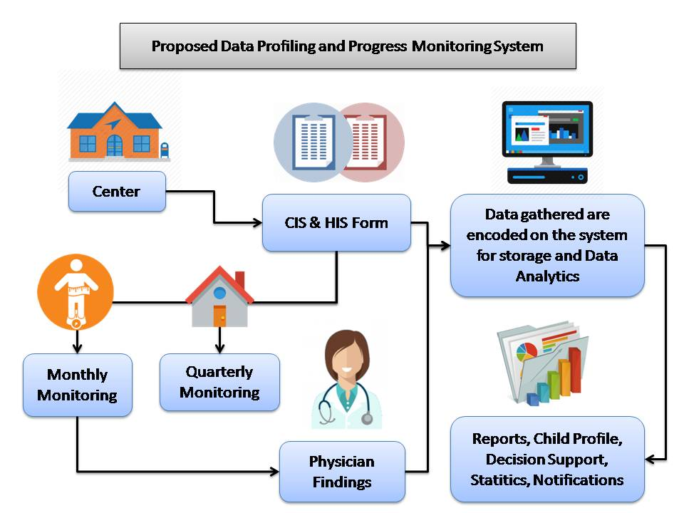
Figure 8: Proposed System

Figure 8 shows the proposed data profiling and progress monitoring application for Archdiocesan Nourishment Center:

The proposed system will help ANC in terms of data profiling and progress monitoring of each child under their program. Data gathered from the Child Information Sheet, Household Information Sheet, Monthly monitoring, Quarterly monitoring and Physician’s findings during check-ups will be encoded on the system for storage and Data Analytics. All data gathered will be stored in a centralized database. This proposed system will analyze the medical and nutritional status of the child, generate recommendations of possible treatments and proper nutritional diet, generate statistical reports in graphical representation, and will give notifications regarding the children that requires immediate medical attention, prioritization and medical schedules.

4. METHODOLOGY
The researchers used the waterfall method for the whole duration of the conducted research. And for the developmental phase, a combination of incremental and iterative scrum in a form of sprint was used.

4.1 Identifying the Opportunities and Problems
The researchers searched for a company that served as the beneficiary of the conducted research. The researchers conducted some interviews to gather and identify problems and requirements and proposed a system that would address these problems.

4.2 Data Gathering
The researchers conducted interviews with Sister Mafel and Sister Melody regarding the current system for the profiling and monitoring of the children in ANC to gather data and information needed for the research. Sample documents needed for the research such as Child Information Sheet and Household Information Sheets were provided. Interviews with the volunteer healthcare professionals in ANC were also conducted. A Physician, Dentist and Nutritionist and Dietician were interviewed and asked research related questions. The researchers made sure to take notes all the important details needed for the study. The researchers believed that all the questions asked during the interview were purely research related and that all the information and idea taken during interview are a big help for the study. The researchers exchanged contacts with the company in case of additional questions and clarifications. The researchers also conducted a thorough research and looked for possible related study through internet and library.

4.2.1 Data Flow Diagram of the Current System

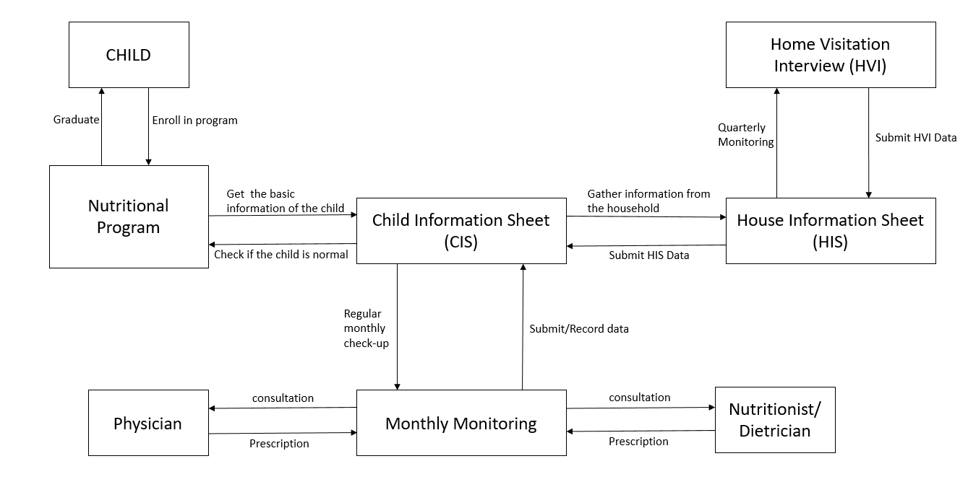
Figure 9: Data Flow Diagram

Figure 9 shows the Data Flow Diagram of the current system of the Archdiocesan Nourishment Center. Each child will be registered in the program, in CIS module each child has a child profile. Each profile consists of data from Household Information Sheet and data from quarterly Home Visitation Interview. Monthly monitoring can be checked and monitored within each profile, monthly data for height and weight will be recorded. (Refer to appendix)

4.3 Analysis and Planning
The researchers analyzed and classified the needs in developing the system. Functional requirements were developed, and Feasibility study was conducted. Also, team members conducted meetings to gather ideas and created a work plan for the whole duration of the development of the system.

4.3.1 Functional Requirements
The following are the functional requirements of the system:

Navigation:
Dashboard Module – this module displays the summary of the data being inputted in the system. It includes a total number of children registered on this day along with a comparison of being registered yesterday, it is presented through percentage. Overall total of children registered in ANC which also states the total number of males and females is also available in the dashboard. The dashboard module also has a list of total children graduated along with the number of children who still need an ongoing treatment. Total family visited or interviewed, total family members and total barangays registered are also in the dashboard. It also pops notifications up.
Statistics and charts – this module displays charts about total children count, number of children grouped by age, monthly child registrations, number of children based on height and based on weight and male and female height and weight observations. These charts are available for printing.
Operations:
Barangays- this section provides a list of barangays where the enrolled children live and when did these were encoded. This is also where the user registers, edits and deletes barangay. A search text box is available to find a specific barangay.

Child Info- this module includes children information sheet which includes a child’s basic information including their initial height, weight, BMI, status upon enrolling and their latest records. Also, there are child’s total days present, absent and active days, date graduated, first date present and last ANC active date. This is also where the user registers, views and deletes a child information as well. A search text box is available to find a child. If a view button is clicked, a child profile is shown. Under this page is where users can edit child info, add household info, add family member, add images and add home visitation record. Data Analytic is viewable also which helps make decision tree.

Attendance -this module records attendance. Children currently enrolled in ANC are listed in this page and users can check their attendance whether they’re present or not during the day. To find specific children easily, search box is available.

Deworming – this module views all children who have undergone deworming. This data includes the child’s ID, Full name, period of deworming, year, date of deworming and date of encoding. This section includes adding a deworming record, editing and deleting.

Monthly Checkup -this module includes a list of children who have undergone a monthly checkup. This data includes child’s ID, full name, month they had been checked up, year, complete date, their heights and weight during checkup and the date it’s encoded. This section includes adding a monthly checkup, editing and record.

Graduated – this module shows the list of graduated children whose profile has already reached normal. Users can add graduated child by clicking the button at the top and select name of a child to be listed as graduated with date and remarks. Editing and deleting are also available as features.

Miscellaneous
Users – this module which is only accessible by admins has a list of all the users who can use the system. This section is where the allowed users can add, delete, and edit user information
System logs – this module shows all the operations done by the logged in users.
Reports - this module which is only accessible by admins generates printable reports such as Child Information sheet active records male and female and Child Information sheet graduated records male and female.
Notification – this module has lists which require actions such as children without monthly checkup, without Home Visitation Interview(HVI), without deworming, and those with severe malnutrition.

4.3.2 Feasibility Study

Technical Feasibility
ANC already has computers that they can use in implementing the proposed system. ANC doesn’t need to purchase another computer because the proposed system is fully functional to use in their current computer units and the basic hardware needed are already available. And because of the availability of computer units in the company, it is now easy to install and run the proposed system.

Economic Feasibility
With the availability of computers in ANC, they will no longer have to purchase another computer unit. But if the company decides to upgrade or purchase another hardware, the company has the budget and is willing to provide more equipment if necessary.

Operational Feasibility
This system is operationally feasible because the proposed system is a user-friendly system and it can be easily installed and operated. For this system, the group will also provide a system manual to help and guide the user how to navigate the commands and functions easily.

4.4 Development

The researchers used a combination of incremental and iterative scrum method in a form of sprint for the whole duration of the development. The development of this application was split into small units. Each sprint is composed of different activities such as Designing, Building, and Testing. In each iteration the system grows feature by feature, this iteration is repeated until the system is stable, functional, fully refined and tested. The researchers used this approach since it allows more flexibility to adapt to changes.
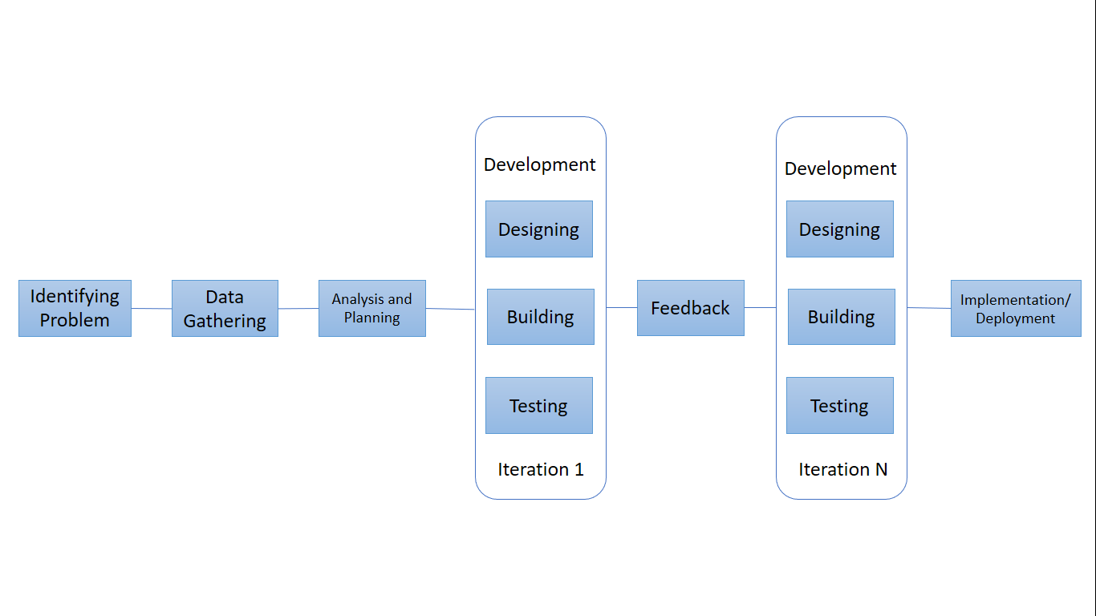
Figure 10: Incremental and Iterative Model

4.5.1 Designing
After identifying the problems, data gathering and analysis and planning, the researchers then created an Entity Relationship Diagram. (Refer to Appendix)

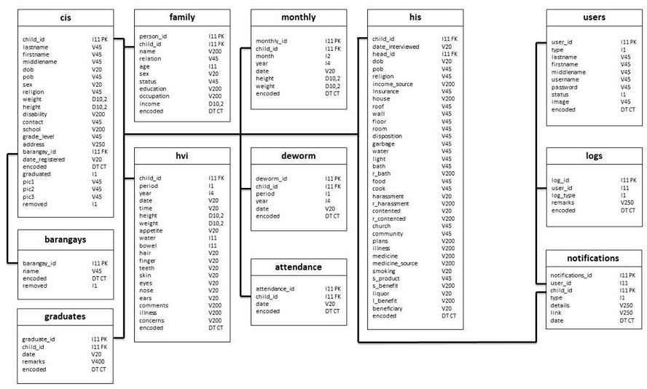
Figure 10: Entity Relationship Diagram

4.5.2 Building
During this phase, the system was developed dividedly into modules such as Dashboard, Statistics/Charts, Barangays, Child Info, Attendance, Deworming, Monthly checkup, Graduated, User, System Logs, Reports and notification. And designed for two types of users: the admin and the staff, the Admin have the privilege to access the whole system while the staff can’t access the users and reports modules. (See figure 12)
The system was developed using HTML5, CSS, Javascript, PHP and MySQL. HTML5 provides the structure of the web pages, CSS is for the designing part, and Javascript is for the client-side processing language that handles the client-side logic of the system. Both Javascript and PHP are for validations, Javascript is for the client side while PHP is for the server-side validation. And MySQL will serve as the database storge.
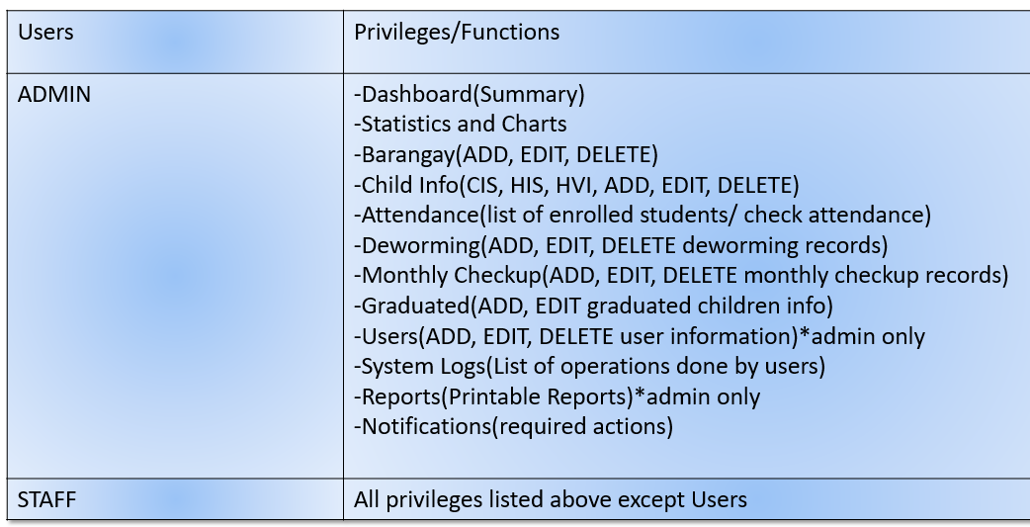
Figure 12: Users and Privileges

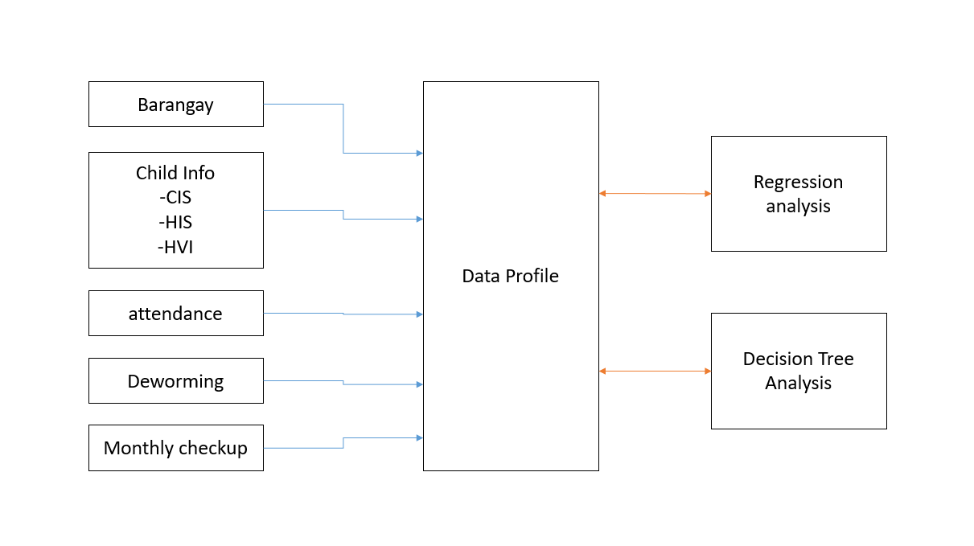
Figure 13: Process of Application
The process starts when a user input data from Barangay, Child Info: Child Information Sheet/Household Information Sheet/ Home Visitation Interview, Attendance, Deworming and Monthly checkup. These data form the whole data profile of the child and are factors for Decision Tree Analysis. While data from CIS such as Age(months), Height(cm) and Weight(kg) are needed for Regression Analysis.

4.5.3 Testing

Table 11: Windows 10 Testing
The system was developed in a windows 10 operating system. It had been run and tested through different kinds of browsers with different versions.
Browser | Version | Result
Microsoft Edge | 38.14393 | passed
 | 41.16299.15 | Passed
Chrome | 52.02743 | Passed
 | 66 | passed
Mozilla | 58.0B4 | passed

Table 12: Windows 7 Testing
The system was installed in the company’s window 7 operating system computer unit. It has been run through different kinds of browsers with different versions.
Browser | Version | Result
Chrome | 6.0.472 | Passed
Mozilla Firefox | 58.0.2 | Passed
Internet Explorer | IE8 | Passed

Table 13: Windows Resolution Testing
The system was run with different screen resolutions to test whether the system adapts to the changes in resolution.
Resolution | Google Chrome | Mozilla Firefox | Microsoft Edge
1366x768 | Passed | Passed | Passed
1360x768 | Passed | Passed | Passed
1280x768 | Failed | Failed | Failed
1280x720 | Failed | Failed | Failed
1024x768 | Failed | Failed | Failed
800x600 | Passed | Passed | Passed

Table 14: Login Component
This section tests whether or not the system accepts an incorrect username and password.
Objective | Description | Expected Result | Remarks
Check if Username and Password are filled | Login Error!  Enter your username and Password | A red colored text will appear at the bottom of the fields | Passed
Check if the username and password are correct | Login Error!  Invalid Username and Password | A red colored text will appear at the bottom of the fields | Passed

Table 15: Dashboard
This section tests if the system summarizes through number the overall data of the system.
Objective | Description | Expected Result | Remarks
View Total of children registered today | *Registered children today  *Percent higher than yesterday | *Total number of children registered that day  *Percentage higher than yesterday | Passed
View Sum of children registered at ANC | *Total Children Registered  *Total Male and Female | *Total number of children being registered or enrolled at ANC with the total number of males and females | Passed
View Total of children graduated | *Total Children Graduated  *Active/Ongoing Treatment | *Total Number of children graduated  *Total number of children who are still on ongoing treatment | Passed
View Total Family Visited/Interviewed | *Total Family Visited/Interviewed  *Latest | *Total number of family they visited or interviewed  *Latest Date they visited or interviewed a family | Passed
View Total Family Members | *Total Family Members  *Average family members | Income | *Total Number of family members  *Average of family members and their incomes | Passed
View Total Barangays Registered | *Total Barangays Registered  *Most children registered | *Total Number of barangays registered  *Barangays with most children registered | Passed

Table 16: Charts
This sections tests if the system provides an accurate graphical representation of the system’s data
Objectives | Description | Expected Result | Remarks
A chart about total children count | Total Children count | Number of children with percentage about graduated female and male and active male and female  *Printable and can be download as image | Passed
A chart about number of children group by age | Number of children grouped by age | A graph about the number of children that are grouped by age  *Printable and can be download as image | Passed
A chart about Monthly Child Registrations | Monthly child registrations for year 2018 | A graph that summarizes the number of children and the month of registration  *Printable and can be download as image | Passed
A chart about the number of children based on height | Number of children based on height (cm) status category | A graph that summarizes and categorizes height of children  *Printable and can be download as image | Passed
A chart about the number of children based on weight | Number of children based on weight (kg) status category | A graph that summarizes and categorizes weight of children  *Printable and can be download as image  *Printable and can be download as image | Passed
A chart that observes Male’s height and weight | Male – Height | Weight Observations | A graph that shows Male height and weight latest data compared to expected date  *Printable and can be download as image | Passed
A chart that observes Male’s height and weight | Male – Height | Weight Observations | Male – Height | Weight Observations  *Printable and can be download as image | Passed
Table 17: Barangay
This section tests if the system allows users to register, edit and delete a barangay.
Objectives | Description | Expected Result | Remarks
Check if barangay name is filled | Barangay name is required | *Barangay name label is highlighted.  *A text will appear at the bottom | Passed
Check if Barangay name changes after save is clicked in edit barangay |  | A barangay name will change after edit | Passed

Table 18: CIS
This sections tests if the system allows users to register, edit and delete a child’s information as well as adding, editing and deleting Household information, home visitation information and family members.
Objectives | Description | Expected Result | Remarks
Check if fields are filled in registering a child | Last name is required  First name is required  Middle name is required  Date of birth is required  Place of birth is required  Gender is required  Religion is required  Initial weight is required  Initial height is required | Last name, First name,  Middle name, Date of birth, Place of birth, Gender, Religion,  Initial weight, Initial height labels are highlighted  *A text will appear at the bottom of each filled | Passed
Check if fields are filled in adding household information sheet | Date interviewed is required  Religion info is required  House information is required  Waste disposal info is required  Garbage disposal info is required  Water source info is required  Bath info is required  Food info is required  Harassment info is required | *Everything that requires to be filled is highlighted  *A text will appear at the bottom of each filled | Passed
Check if fields are filled in adding household visitation interview | Period is required  Year is required  Date is required  Time is required  Current height is required  Current weight is required  Appetite is required  Water is required  Bowel is required  Hair is required  Teeth is required  Skin is required  Eyes is required  Nose is required  Ears is required | Everything that requires to be filled is highlighted | Passed
Check if information change after save is clicked in edit child info |  | Information will change after edit | Passed
Check if information change after save is clicked in edit home visitation interview |  | Information will change after edit | passed

Table 19: Attendance
This sections tests if the system allows the user to mark a child as present or absent.
Objectives | Description | Expected Result | Remarks
Check if the number of present children are changed after check button is clicked |  | the number of present children will change after check button is clicked | Passed

Table 20: Deworming
This sections tests if the system allows the user to add, edit and delete deworming record
Objectives | Description | Expected Result | Remarks
Check if Full name, period year and date are all filled | Child is required  Period is required  Year is required  Date is required | *Everything that requires to be filled is highlighted  *A text will appear at the bottom of each filled | Passed
Check if information change after save is clicked in edit child info |  | Information will change after edit | Passed
Check if information Deleted after delete is clicked |  | The data will be deleted | Passed

Table 21: Monthly Monitoring
This sections tests if the system allows users to add, edit, and delete monthly monitoring record of a child.
Objectives | Description | Expected Result | Remarks
Check if fields are filled in adding monthly checkup | Child is required  Month is required  Year is required  Date is required  Current height is required  Current weight is required | *Everything that requires to be filled is highlighted  *A text will appear at the bottom of each filled | Passed
Check if information change after save is clicked in edit monthly checkup record |  | Information will change after edit | Passed
Check if information Deleted after delete is clicked |  | The data will be deleted | Passed

Table 22: Graduated
This sections tests if the user can select students to mark as graduate.
Objectives | Description | Expected Result | Remarks
Check if fields are filled in adding graduate child record | Child is required  Date is required | *Everything that requires to be filled is highlighted  *A text will appear at the bottom of each filled | Passed
Check if information change after save is clicked in edit graduate child record |  | Information will change after edit | Passed
Check if information Deleted after delete is clicked |  | The data will be deleted | Passed

Table 23: User
Objectives | Description | Expected Result | Remarks
Check if fields are filled in adding user | Username is required  Password is required  Last name is required  First name is required  Middle name is required  Email is required  Address is required | *Everything that requires to be filled is highlighted  *A text will appear at the bottom of each filled | Passed
Check if information change after save is clicked in edit user |  | Information will change after edit | Passed
Check if information Deleted after delete is clicked |  | The data will be deleted | Passed
Check if Users module is not accessible by staff |  | Users button will not appear in the tabs | Passed
Check if only admins can access the Users module |  | Users button will appear in the tab | Passed

Table 16: Logs
Objectives | Description | Expected Result | Remarks
Check if the activity done is being shown in this module |  | The activity done is being shown in this module | Passed

Table 17: Reports
This section generates any selected reports with filtering data.

Objective | Expected result | Remark
Check if report module is not accessible by staff | Report button will not appear in the tabs | Passed
Check if only admins can access the report module | Report button will appear in the tab | Passed
Check if the system can generate CIS Report | Users can select what type of report to be generated | Passed
Check if the system can generate Monthly Monitoring Report | Users can select what type of Monthly report (Male or Female), what month period, and what year to generate | Passed
Check if the system can generate Child profile report | Users can select child information to be generated | Passed
Check if all the reports are printable | Users can print the desired report | Passed

Table 18: Schedule
This section tests if the system can set a schedule.
Objective | Description | Expected Result | Remarks
Check if the system can add a schedule | Add new Schedule | A form will pop up for scheduling | Passed
Check if the system checks if all the fields are filled | *Schedule title is required  * Schedule date is required  *Schedule time is required  *Schedule remarks is required | Schedule will not be added if all the fields are filled | Passed
Check if the system can edit a schedule |  | A selected schedule will be edited after the save button is clicked | Passed
Check if the system can delete a schedule |  | A selected schedule will be deleted after the deleted button is clicked | Passed
Check if the system notifies a schedule in the page alert | Appointment Schedule today | The name of the schedule will appear in the page alert | Passed
Checks if the system highlights a schedule depending on its status | Green – Today  Gray – Ended  White – Incoming | A schedule highlighted in green means the schedule is today  A schedule highlighted in grey means the schedule has ended  A schedule highlighted in white means the schedule is incoming | Passed

Table 19: Notifications
This section tests if the system notifies the user about the actions to be done.

Objective | Expected Result | Remarks
Checks if the names of the children with no monthly check up will notify the user | A list of children with no monthly checkup will appear in the notification section under No Monthly Checkup | Passed
Checks if the names of the children with no HVI (Quarterly) checkup will notify the user | A list of children with no HVI (Quarterly) will appear in the notification section under No Monthly Checkup | Passed
Checks if the names of the children with no Deworming will notify the user | A list of children with no Deworming will appear in the notification section under No Monthly Checkup | Passed
Checks if the names of the children with Severe malnutrition will notify the user | A list of children with Severe malnutrition will appear in the notification section under No Monthly Checkup | Passed
Checks if notifications will pop up in the dashboard | Notifications will pop up in the dashboard | Passed

4.6 Implementation and Deployment
For the Implementation phase, the system was developed in a Windows 10 Operating system. Coded in sublime application and Mysql in database. It was implemented on different kinds of browsers such as Google Chrome, Mozilla Firefox and Microsoft Edge.
For the deployment phase, the system was installed in a windows 7 operating system along with the XAMPP application for the database handling. The system is compatible with their operating system. The researchers trained the staff of Archdiocesan Nourishment Center on how to operate the entire system. The different modules were discussed to them one by one including its functionalities. The researchers also provided a user manual to guide users on how to use the system.

5.1 RESULTS AND DISCUSSIONS
During testing and deployment at Archdiocesan Nourishment center, first, the researchers installed XAMPP for database handling then they configured it to match the time zone in the Philippines and to autorun the application upon startup, the application run smoothly in all types of browsers particularly in Google Chrome since it’s up to date. It works fine also in their desktop platform with Windows 7 operating system. Then the researchers tested the stand-alone application in the browser and did not see or encounter any problems while running. All its functionalities were carefully and repeatedly tested to make sure errors and bugs are trapped. The researchers also inputted the children’s profiles and their other data into the system so that the company won’t undergo the process of inputting all of the data which apparently takes a lot of time. This helps for the teaching part because with the available data in the system, the researchers can easily explain the process. The researchers have also trained their employees on how to use the system, they let them input too as part of the training. All of its parts and functions have been discussed to them one by one to make sure that they have carefully understood its uses.
Overall, the result of the deployment and training had gone smoothly and well.

5.2 Summary and Recommendations
After indicating the result, the researchers observed that the system performed well while they tested it on the ANC computer unit with a processor of Intel Celeron E3400 and a RAM of 2GB and an operating system of a windows 7.
Based on the findings of the study, this is a recommendation for future enhancement of the stand-alone application for future researchers: Stand-alone application should put up a more secure feature for database handling since some or almost all companies handle confidential information that need not to be disclosed.
Aside from security, another is standalone application platform dependency which requires a local runtime environment. A windows form application will only be run on a windows platform with the .NET framework installed so in the future system development, any standalone application should run in any platform regardless of its form. Also, this standalone could be converted to web-based system for wide range of usage. Lastly, the future developed systems that cover graphs and other data structures should have an extensive and detailed visual presentation such as 3D visualizations because it gives a more effective and clear statistical report.

REFERENCES

- Ling, Z., Tran, Q., Fan, J., Koh, G., Nguyen T., Tan, C., Yip, J. and Zhang, M. (2014). National University Health System. National University of Singapore.
- Khazaei, H., McGregor, C., Eklund M., El-Khatib, K. and Thommandram, A. (2014). University of Ontario Institute of Technology Oshawa, Canada
- M. S. Kramer, R. W. Platt, H. Yang, K. S. Joseph, S. W. Wen, L. Morin, and R. H. Usher. (2014) Secular trends in preterm birth: A hospital-based cohort study
- Tang, Q. and Zhang, C. (2013). Institute of Insect Science, Zhejiang University, Hangzhou, China
- Thilakanathana, D., Chenb,Y. ,Nepal S., Calvoa, R. and Alemb L. (2013). The University of Australia
- Demirkhan, H. and Delen, D. (2013). The Milgard School of Business, University of Washington Tacoma, United States. Department of Management Science and Information Systems, Spears School of Business, Oklahoma State University, United States.
- Murphy, Shawn; Goodson, Alyssa; Mendis, Michael; Murphy, Marykate; Phillips, Lori; Yanbing Wang; Herrick, Christopher. (2016). IADIS International Journal on Computer Science & Information Systems
- Raghupathi, W., and Raghupathi, V. (2014). Raghupathi and Raghupathi Health Information Science and Systems. https://www.biomedcentral.com/track/pdf/10.1186/2047-2501-2-3?site=hissjournal.biomedcentral.com
- Sun, J., and Reddy, C. (2013). ACM DIGITAL LIBRARY. IBM TJ Watson Research Center, Yorktown Heights, NY, USA and Wayne State University, Detroit, MI, USA.
- Waljee, A.K., P.D.R. Higgins& A.G. Singal. (2014). A primer on predictive models. Clin. Transl. Gastroenterol.
- Popovic, J. (2016). Harvard Medical School/Harvard Pilgrim Health Care Institute, Boston, Massachusetts
- Tan, S., Gao, G. and Koch, S. (2016). Centre for Health Informatics, Department of Information Systems, National University of Singapore, Singapore; Center for Health Information and Decision Systems, University of Maryland, College Park, USA; Health Informatics Centre, Department of Learning, Informatics, Management and Ethics, Karolinska Institute, Stockholm, Sweden
- https://www.techopedia.com/definition/26418/data-analytics
- http://searchcio.techtarget.com/definition/decision-support-system
- https://hbr.org/2015/11/a-refresher-on-regression-analysis
- http://study.com/academy/lesson/what-is-a-decision-tree-examples-advantages-role-in-management.html

